Retrieve Container Data in Windows 8 Apps
Step 1: Create storage.
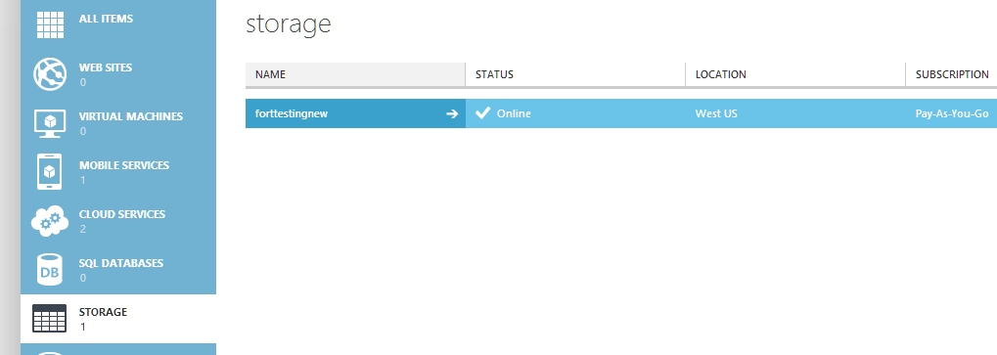

Step 2: Create Container. Set to Public Container.
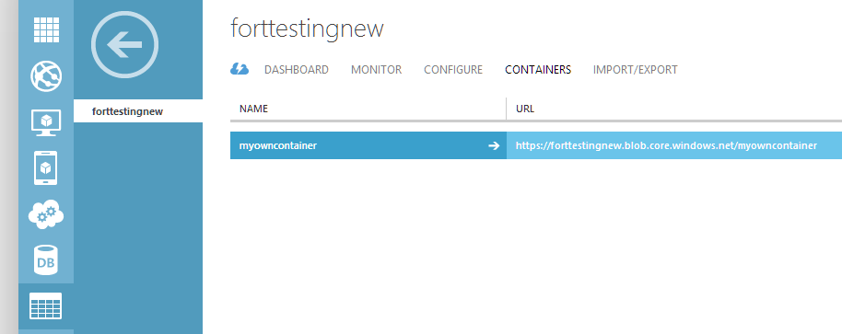
Upload the Images using Azure Storage Explorer tool or app.

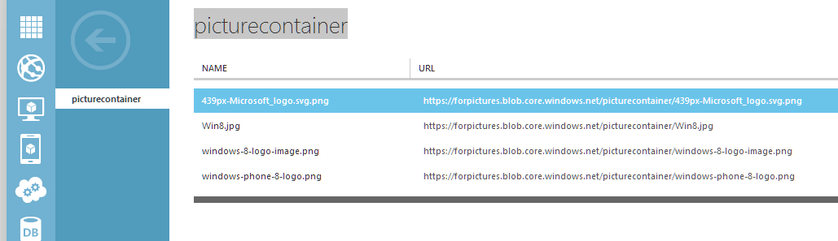

Step 3: Start Visual Studio Create Windows 8 New XAML/ C# App.
Right click on “References” & select “Manage NuGet Packages…”
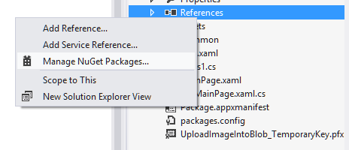

Enter the term for search “Windows Azure Storage”

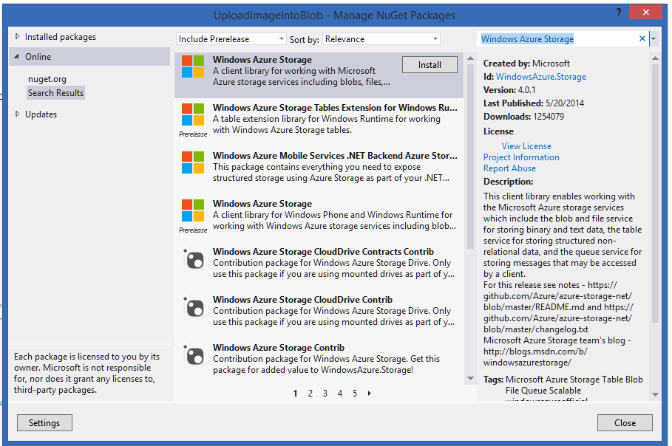

Step 4: after installation Windows Azure Storage Package or DLL added to the App.

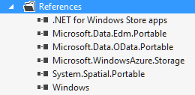

Step 5: Open MainPage.xaml file
<Grid Background="{StaticResource ApplicationPageBackgroundThemeBrush}">
<ListBox x:Name="myListBox">
<ListBox.ItemTemplate>
<DataTemplate>
<StackPanel Orientation="Horizontal">
<TextBlock Text="{Binding}" Height="200" Width="1000"/>
<Image Source="{Binding}" Height="100" Width="100"/>
</StackPanel>
</DataTemplate>
</ListBox.ItemTemplate>

</ListBox>
</Grid>

Step 6: Open MainPage.xaml.cs file
Add few references

using Microsoft.WindowsAzure.Storage;
using Microsoft.WindowsAzure.Storage.Auth;
using Microsoft.WindowsAzure.Storage.Blob;
using System.Diagnostics;

protected async override void OnNavigatedTo(NavigationEventArgs e)
{
var credentials = new StorageCredentials("fortestingnew", "96OdFITud72q8RTfhsJeM1i1Yov8Qlrk9sXLBKOjh7FtOsxYV3klrScv7AE53R8keH9Ylj8JTbBSf177wBDjIw==");
var account = new CloudStorageAccount(credentials, true);
var blobClient = account.CreateCloudBlobClient();
var container = blobClient.GetContainerReference("myowncontainer");
await container.CreateIfNotExistsAsync();
BlobContinuationToken x = new BlobContinuationToken();
BlobResultSegment result = await container.ListBlobsSegmentedAsync(x);

List<string> dataSet = new List<string>();
foreach (var item in result.Results)
{
dataSet.Add(item.Uri.AbsoluteUri);
//Debug.WriteLine(item.Uri.AbsoluteUri);
}

myListBox.ItemsSource = dataSet;

//container.ListBlobsSegmentedAsync(string.Empty, true, Microsoft.WindowsAzure.Storage.Blob.BlobListingDetails.All, null, tokenSource);
}

Now run the App.
Retrieving the url & image.
